iStick User Manual

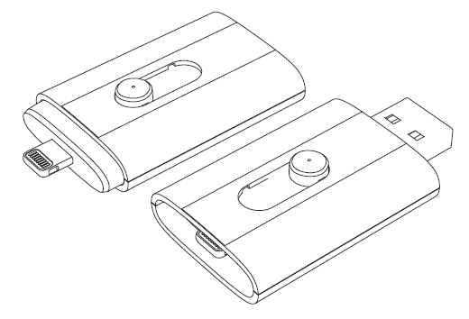

Revision 1.3

Table of contents

- Introduction
- Box Contents
- System Requirements
- Physical Descriptions
- iStick App Installation
- Using iStick App
  - iStick App Description
  - Navigating Around The App
  - “Edit” Function
  - Create New Folder
  - Copy/Move Files
  - Formatting iStick
  - Opening A File
  - Music Playback
  - Video Playback
  - Photo Library
  - Contacts Backup
  - About

- Introduction

iStick is a USB flash drive with an integrated Apple Lightning connector that not only works with Mac/PC computers but also with iOS devices (iPhone, iPad, iPod touch) as well. iStick allows users to:
- Easily transfer files between Mac/PC computers and iOS devices (iPhone, iPad, iPod touch)
- Perform file management (Copy, Paste, Delete etc.) on Mac/PC, iOS devices and iStick
- Browse and open documents, photos, music and video files stored on iStick and iOS device with aid of a free companion iOS app
- Backup and restore iOS contact list
- Use iStick as an ordinary USB flash drive on Mac and PC

- Box Contents

- iStick
- Quick Reference Guide

- System Requirements

- iOS device: iPhone 5/5s/6/6 Plus, iPad mini, iPad mini with Retina display, iPad (4th generation), iPad Air, iPod touch (5th generation) and later models
- iOS: iOS 6.x/7.x/8.x and above
- PC: Windows XP/7/8 and above
- Linux 2.6.x and above
- Mac OS 10.x and above

- Physical Descriptions

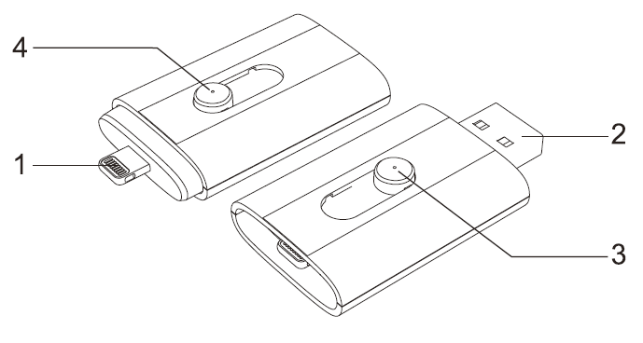

No. | Name | Description
1 | Apple Lightning Connector | Connector to iOS devices
2 | Standard USB Connector | Connector to Mac/PC
3 | Sliding Switch | Slide to chose between Apple Lightning and USB connector
4 | LED | Operating status indicator

- iStick App Installation (as shown on an iPhone 5s running iOS8)

There are four ways to install the iStick App as described below.

Note:
App installation requires an Apple ID and Internet connection to perform. If you do not have an Apple ID, please refer to the following links to apply for an Apple ID:
English: http://support.apple.com/kb/HT5622
Chinese: http://support.apple.com/kb/HT5622?viewlocale=zh_CN&locale=en_US

Method 1: Automatic Installation
Connect the iStick to the iOS device, a “App Not Installed” dialog box will pop up.

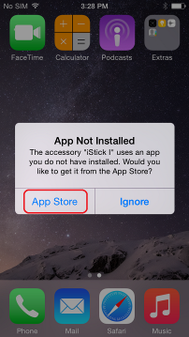
Select the “App Store” option to be brought to the App Store to find and download the iStick app.

Note:
Be sure to select the “App Store” option, if you select “Ignore”, the “App Not Installed” dialog box would not show up again. If that happens, please follow Method 2 to install the app.

Find the iStick app, tap the “FREE” button followed by the “INSTALL” button to install the app.
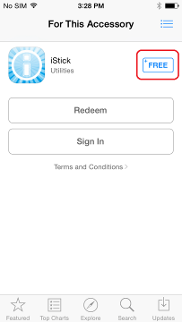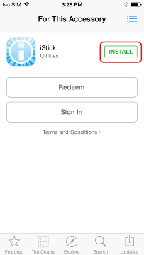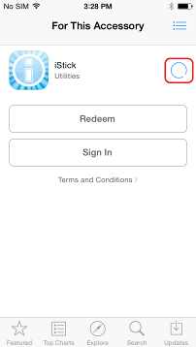
Enter your Apple ID and password to download the app.
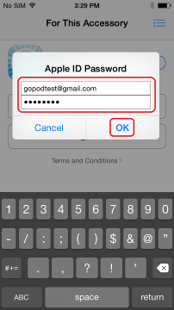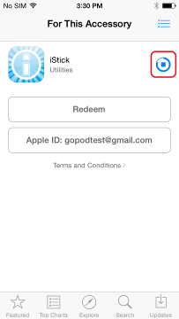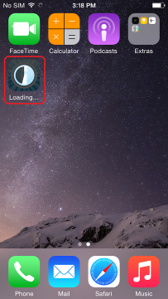
After installation is completed, tap the "OPEN" button or tap on the iStick app icon on the home screen to start the app.

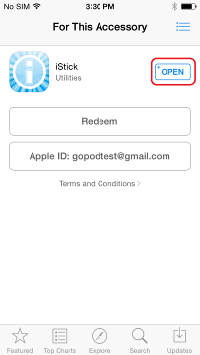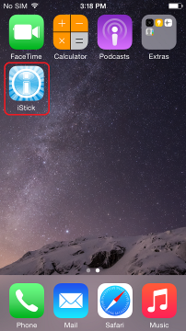

Method 2: Find App for Accessory in Settings
If you select the “Ignore” option in the “App Not Installed” dialog box in Method 1, you can use the following method to find and download the iStick app.

Go to Settings > General

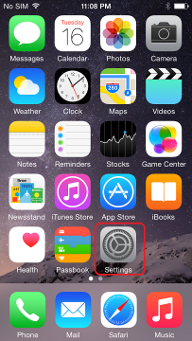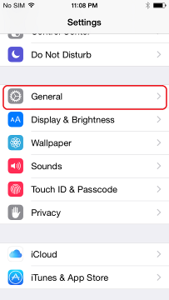

On the next screen, select About > iStick I
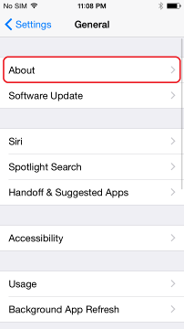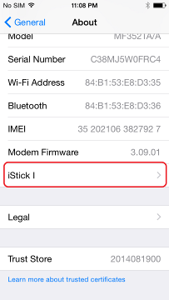
Select “Find App for Accessory” and install the iStick app.
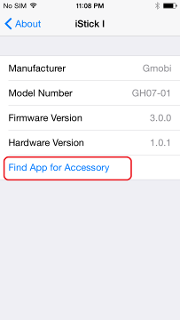
Method 3: Find iStick app on the App store
Open “App Store”
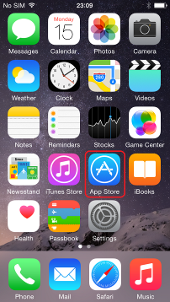

Search for "iStick"

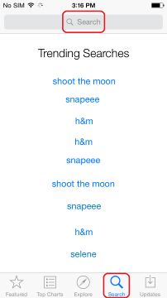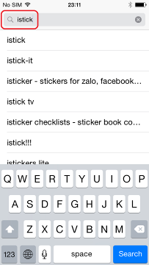

Find and install the iStick app

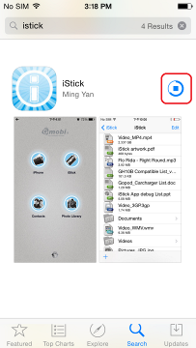

Method 4: Install iStick app via computer iTunes
Connect iOS device to the computer and open iTunes.
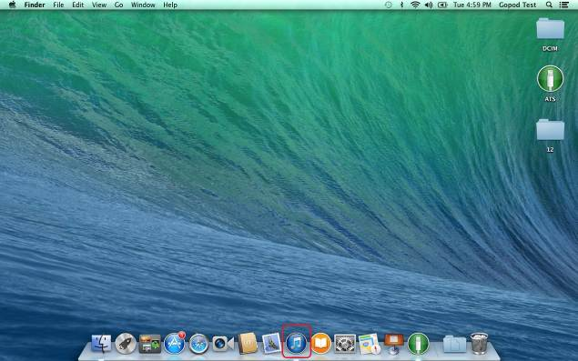

Select “iTunes Store”

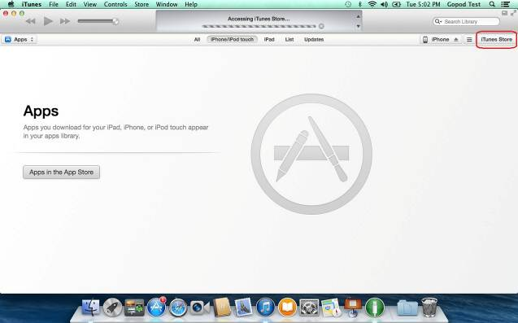

Search for “iStick”

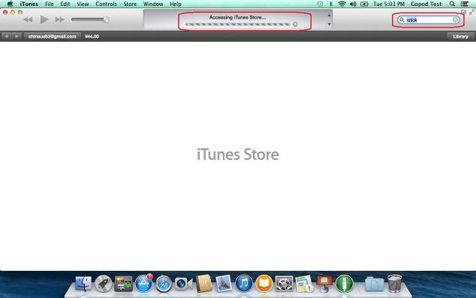

Select “iStick” app

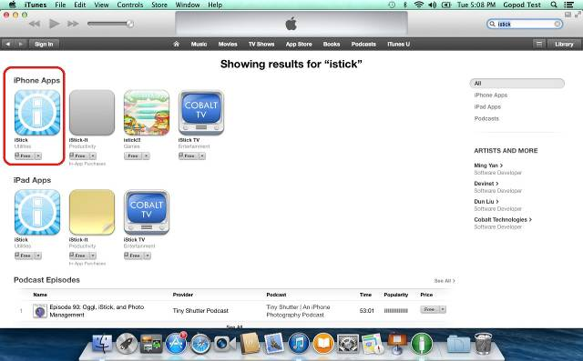

Select FREE > DOWNLOAD

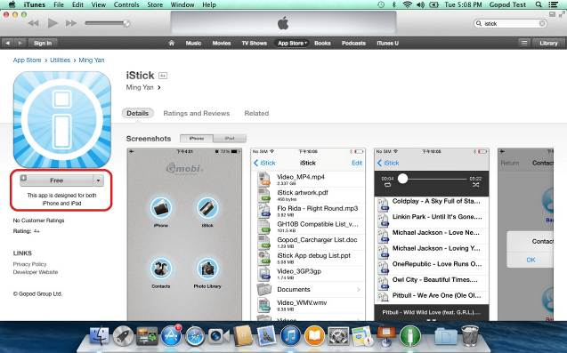

Enter Apple ID and password

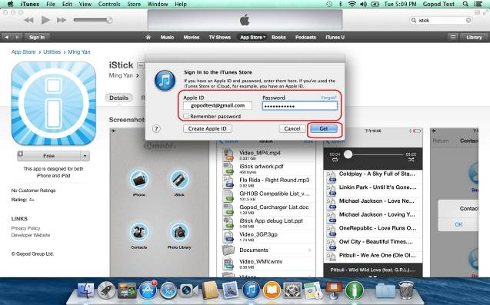

Wait for app to download

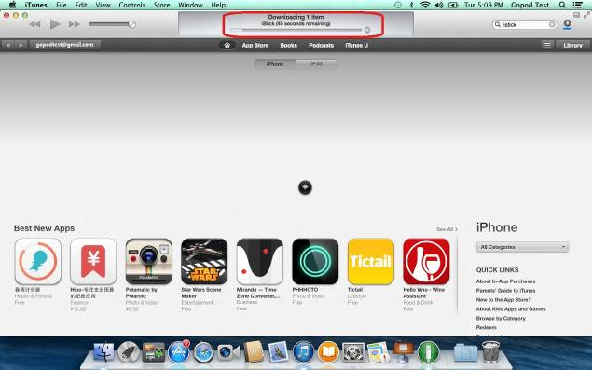

Once the app is downloaded, select “Install”

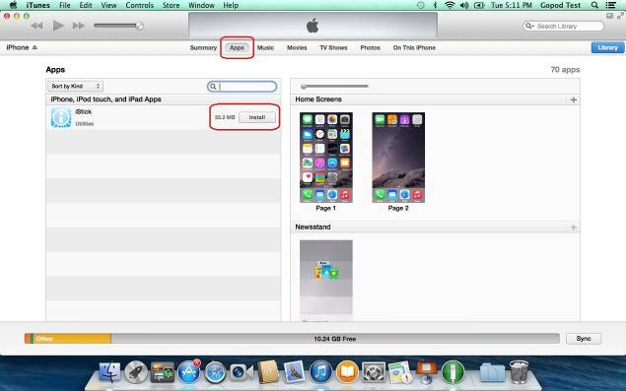

Click "Apply" button to install the app onto the iOS device

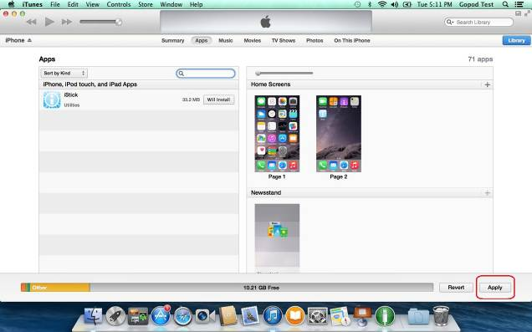

Wait for app to install

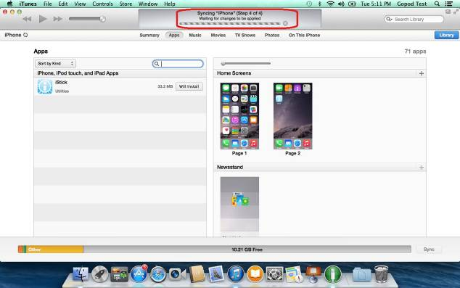

After app installation is completed, the iStick app will appear on the iOS device home screen.

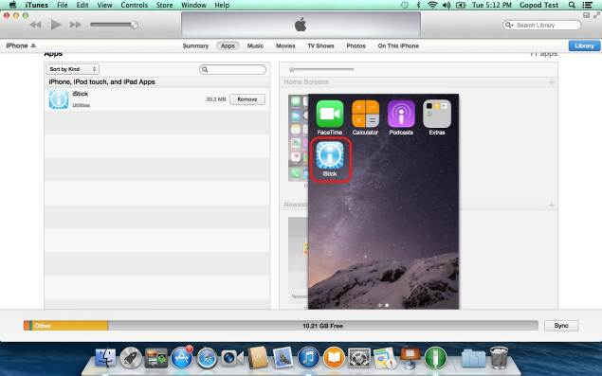

- Using iStick App

With the iStick app installed, connecting the iStick hardware to the iOS device will automatically trigger a dialog box requesting permission for the iStick app to communicate with the iStick. Select “Allow” or just tap the iStick app icon to start the app.

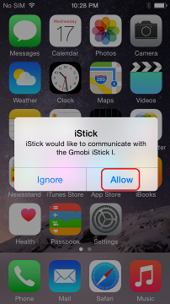

  - iStick App Description

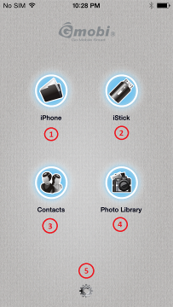

No. | Name | Description
1 | iPhone (if iStick is connected to an iPhone)  iPad (if iStick is connected to an iPad) | Browse local files stored within the iStick app on the iPhone/iPad
2 | iStick | Browse files stored on iStick
3 | Contacts | Contacts Backup & Restore
4 | Photo Library | Select photos to backup to iStick
5 | About | Support information

  - Navigating Around The App

From the app main menu, tap on the “iPhone” or “iPad” icon to browse the local files currently stored in the iStick app on the iPhone/iPad
Description of functions
“Return”: Return to the previous page (e.g. app main menu)
The main area displays a list of files/folders which you can Edit or create a new folder
“Edit”: Select this to delete/copy/move files and folders
“+”: Select to create a new folder
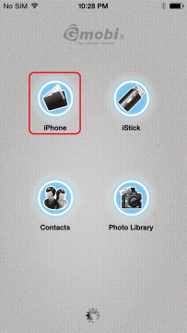 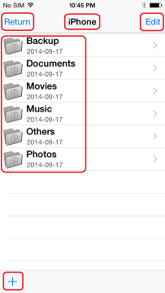

  - “Edit” Function

“Select All”: Selects all files and folders
“Deselect All”: Unselects all files and folders
“Cancel”: Cancel operation
Tools at the bottom of the page: Delete, Copy, Move, Email

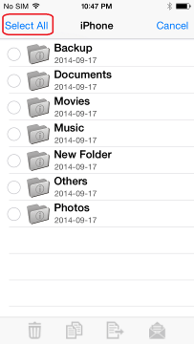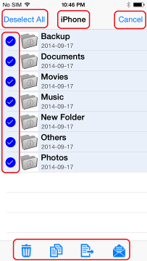

  - Create New Folder

Tap on “+” to create a new folder. Enter a name for the new folder and tap “Enter”

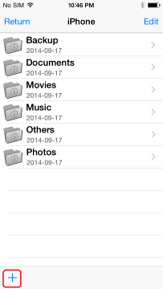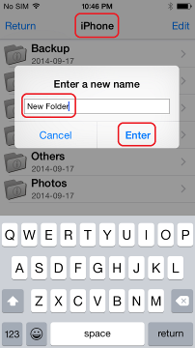

  - Copy/Move files

Open any folder (e.g. Photos) and select “Edit”

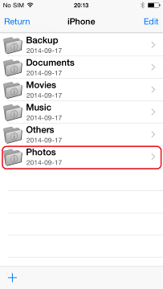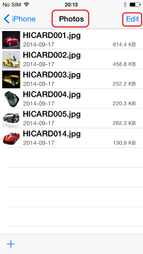

Select the files and choose the “Copy” or “Move” icon from the bottom toolbar and select the destination (e.g. iPhone, iStick or Camera Roll)

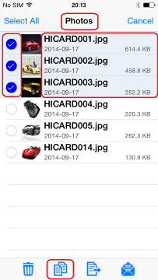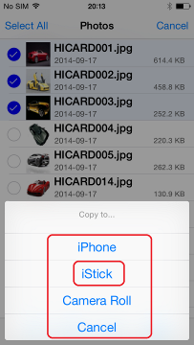

Select the destination folder (e.g. Copy) and select “Copy to here”

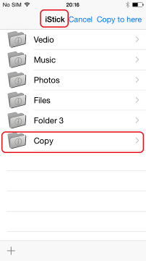

The copy progress will be displayed. Once copy is complete, you can open the destination folder to verify that the files have been copied over.

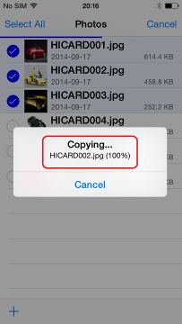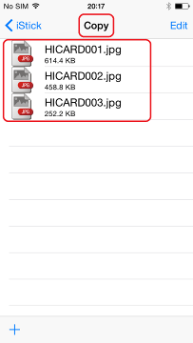

Note :
You can follow the above steps to perform Delete, Move and Email function by choosing the appropriate icon at the bottom toolbar.

  - Formatting iStick

To format and erase all contents on the iStick, select the format icon at the lower right corner as shown and select “Continue” in the pop-up “Warning” dialog box.

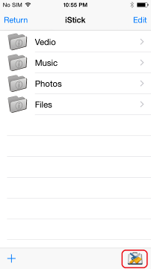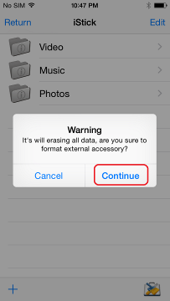

The formatting progress is shown at the top of the screen.

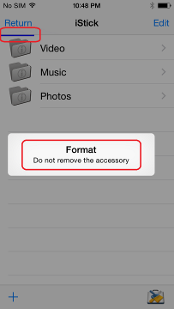

Note:
Do not remove the iStick while it is formatting. Otherwise it may become unrecognizable to connected devices and you will have to reformat the iStick again with a computer.

  - Opening a file

Click on iStick icon in the app main menu to browse files and folders on the iStick. Tap on a folder (e.g. Files) to enter that folder. Tap on any file to open it.

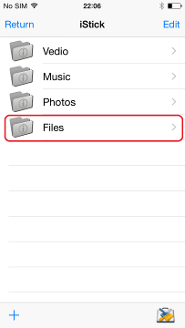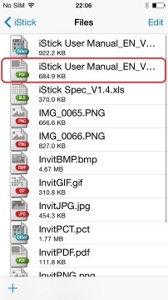

Tap on the upper left corner to go back to folder view.

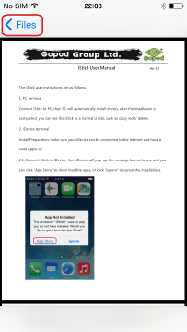

  - Music Playback

Tap to enter the “Music” folder and tap on any music file to start music playback.

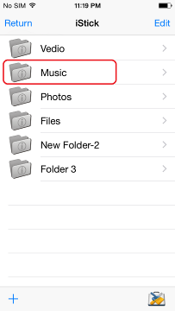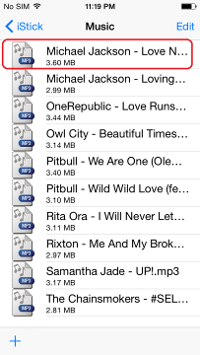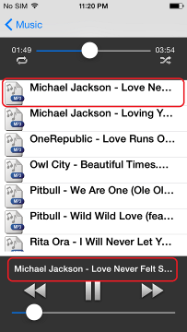

Music Player Interface

No. | Icon | Description
1 | Loop | Play song in a loop
2 | Shuffle | Shuffle song playback
3 | Progress Bar | Indicates the playback progress of the song. Drag to start playback at any point of the song.
4 | Volume Control | Adjust playback volume
5 | Previous Track | Play previous song
6 | Play / Pause | Play / Pause
7 | Next Track | Play next song
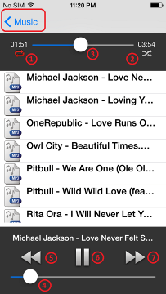

  - Video Playback

Tap to enter the “Video” folder and tap on any video file to start playback.

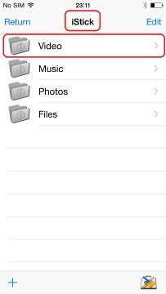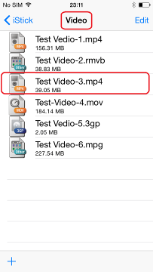

Video playback

Video Player Interface

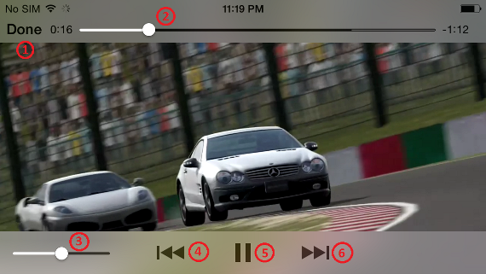

No. | Icon | Description
1 | Done | Exit video player
2 | Progress Bar | Indicates the playback progress of the video. Drag to start playback at any point of the video.
3 | Volume Control | Adjust playback volume
4 | Previous Track | Play previous video
5 | Play / Pause | Play / Pause
6 | Next Track | Play next video

  - Photo Library

This feature allows you to access the iOS device photo library, from which you can select photos to copy from the iOS device to the iStick.

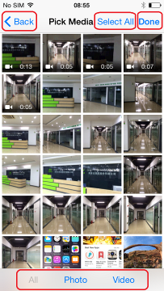

Photo Library Description
“Back”：Return to previous page
“Select All”: Select all the Photos/Videos files
“Done”: Done with selection
“All”: List both Photo and Video files
“Photo”: List only Photo files
“Video”: List only Video files

Listing Photo files only

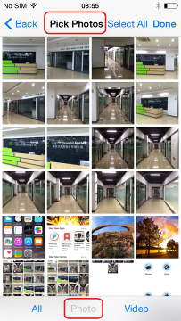

Listing Video files only

Select the files you want to copy and tap “Done”

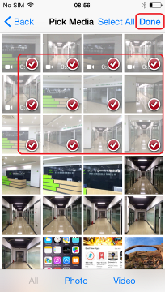

Select the destination (e.g. iStick)

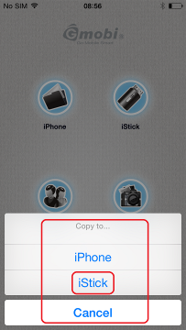

Browse to a folder (e.g. Copy)

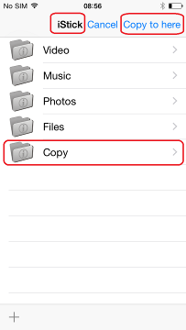

Tap “Copy to here”

The copying progress will be shown.

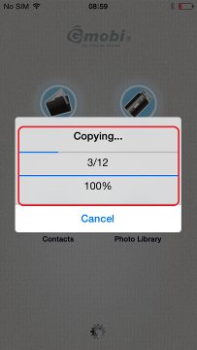

Files will appear in the destination folder after copying is done.

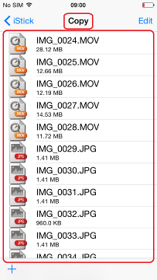

  - Contacts Backup

You can use the iStick and the iStick app to backup and restore your iOS contacts. First you need to ensure that the iStick app has access to your contacts. Go to Settings > Privacy > Contacts > Enable iStick app

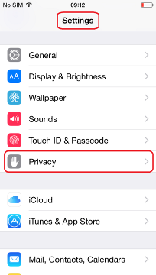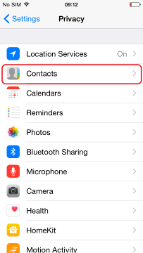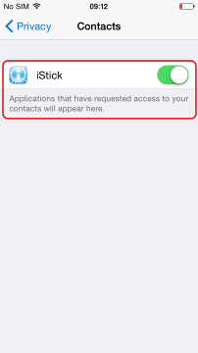

A “Warning” dialog box will pop up If there are no iOS contacts available

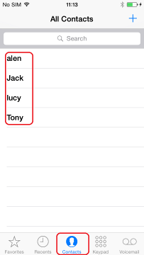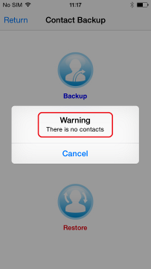

Tap on "Contacts" icon and tap "Backup" to perform contacts backup

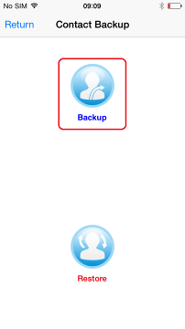

In the "Contact Backup" pop-up, tap "OK"

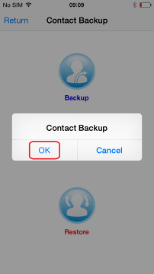

Tap “OK” when Contact backup finishes to exit

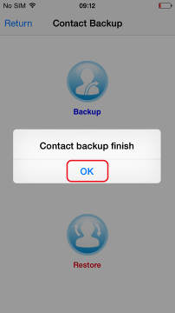

Contacts will be backed up in the iStick “Contacts Backup” folder as a .ab backup file.

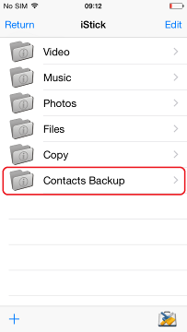

To restore contacts, tap “Restore” in the “Contact Backup” section

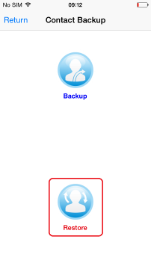

Tap “OK” in the pop-up dialog box

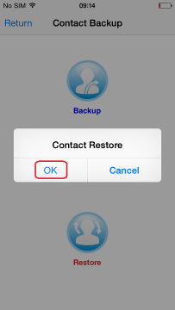

Tap "OK" to confirm the “Contacts Restore”

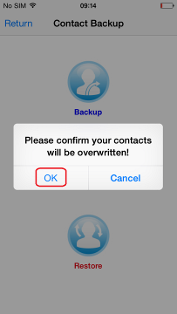

In the “Contacts Backup” folder, select the .ab address book file that you want to restore from.

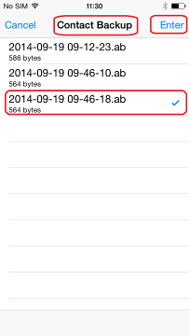

Tap “OK” to exit “Contact Restore” and you can verify that the contacts are indeed restored to the iOS contacts directory.

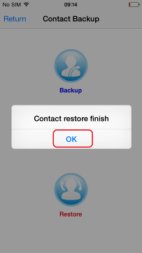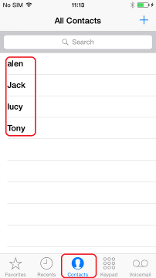

  - About

“Done”: Return to the main menu
“iStick v2.8.6”: Current iStick app version
“Operating Instructions”: iStick app user manual
“Support”: Online help information
“Report Bug”: Email bugs/feedback about the app

